Problema 1:

select employees.first_name as prenume_zdc ,employees.last_name as nume_zdc,departments.department_name as departament_zdc,jobs.job_title as serviciu_zdc

from (employees join jobs on employees.job_id=jobs.job_id)left outer join departments on employees.department_id=departments.department_id

where salary in (select employees.salary from (employees left outer join departments on employees.department_id=departments.department_id)

join locations on locations.location_id=departments.location_id where upper(locations.state_province) like 'OXFORD')

and commission_pct in (select employees.commission_pct

from (employees left outer join departments on employees.department_id=departments.department_id)

join locations on locations.location_id=departments.location_id where upper(locations.state_province) like 'OXFORD');

--35 rezultate

* Am folosit join pentru a avea acces la toate datele din employees si din locations si am facut asta prin tabelul departments, am folosit subcereri pt a selecta salariile respectiv comisioanele din emloyees care lucreaza in Oxford

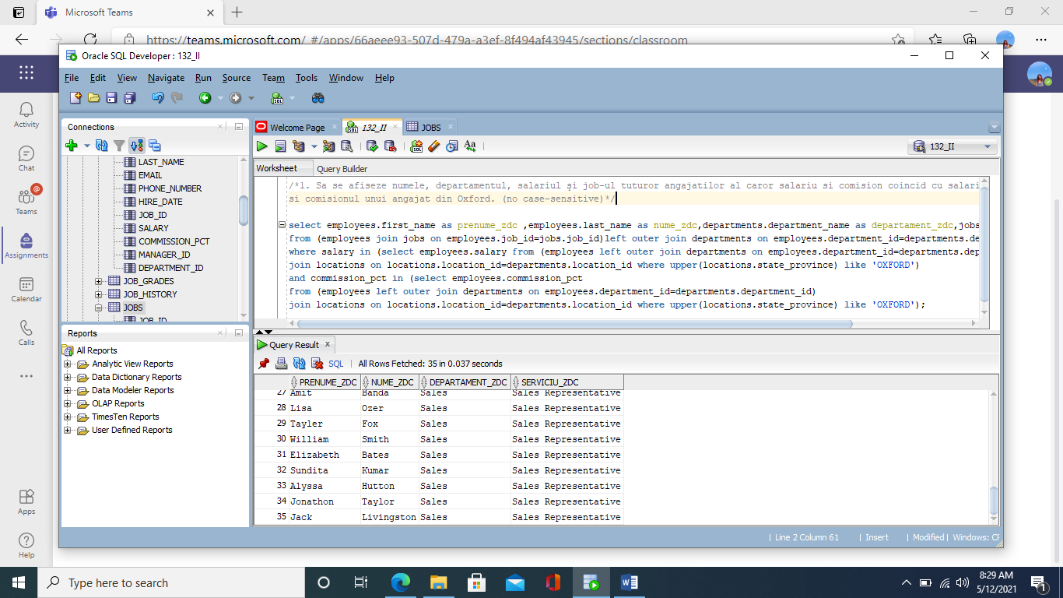

Problema 2:

select employees.employee_id as ID_zdc, employees.last_name as nume_zdc , employees.first_name as prenume_zdc, jobs.job_title as serviciu_zdc ,

departments.department_name as departamentul_zdc, employees.salary as salariu_zdc, a.medie as medie_zdc

from (employees join jobs on employees.job_id=jobs.job_id)left outer join departments on

employees.department_id=departments.department_id ,(select Min(avg(salary)) medie from employees group by job_id) a

where employees.salary>a.medie;

--90 rezultate

--similara problemei 3

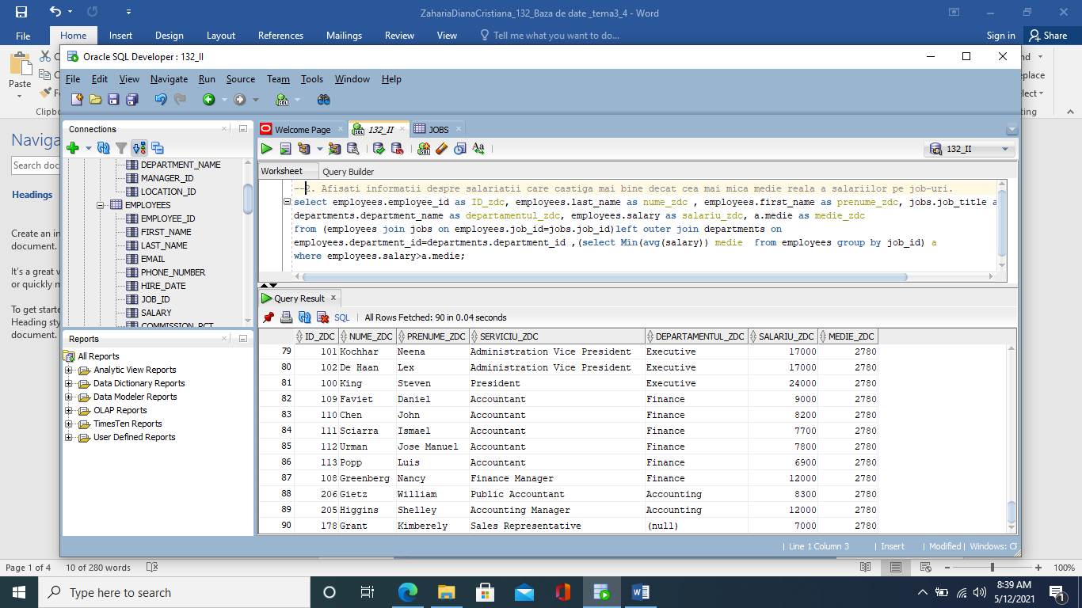

Problema 3:

select employees.last_name as nume_zdc, employees.first_name as prenume_zdc,employees.job_id as job_zdc, employees.salary as salariu_zdc, a.medie as medie_zdc

from employees , (select job_id job, avg(salary) medie

from employees

group by job_id) a

where employees.job_id = a.job and employees.salary > a.medie;

* Am folosit o subcerere pentru a selecta jobul impreuna cu media reala a salariului corespunzator lui si apoi in conditia where am rezolvat cerinta .

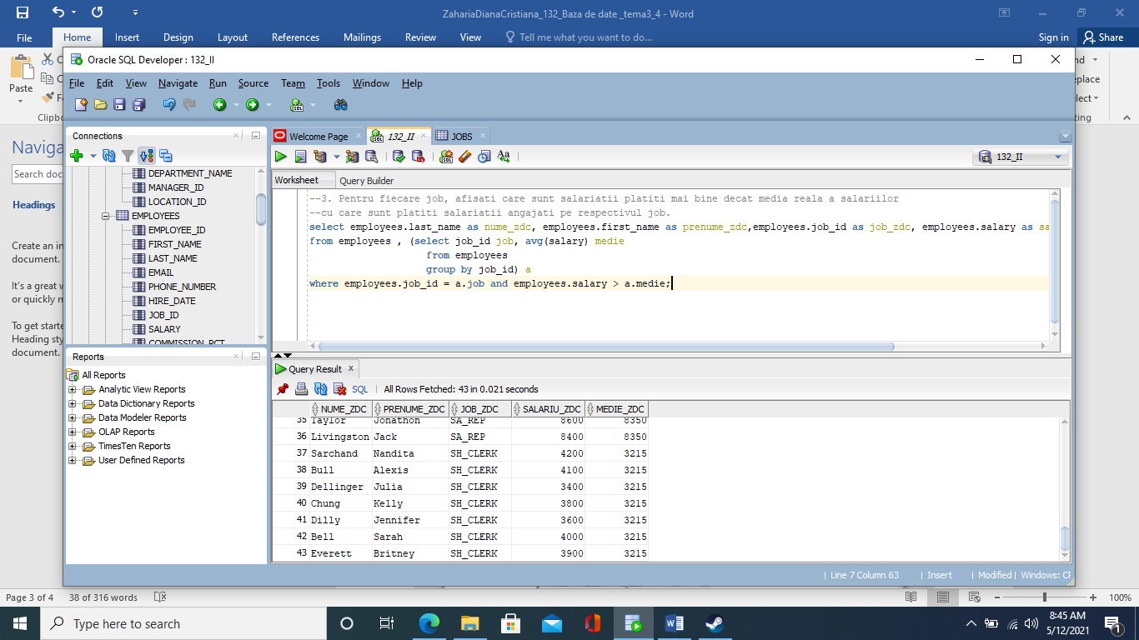

Problema in plus :

select *

from jobs

where job_id=(

select a.job_id

from (select job_id,count(job_id) maxim1

from employees

group by job_id) a, (select max(count(job_id)) maxim2

from employees

group by job_id) b

where a.maxim1=b.maxim2);

--1 rezultat

-- am folosit functia count pt a afla de cate ori apare un anumit job_id ajutandu-ma de functia group by, am folosit max pentru a afla care e cel mai mare nr de aparitii, apoi prin subcerere am aflat carui job_id ii corespunde ca apoi prin alta subcerere am afisat datele acestuia.

